Alex Arnold
Professor Torres
4-17-25
IT 120-41198
Lab 11

Part A: NETLAB Security+ v4: Identify and Analyze Network/Host NDS/IDS Alerts
NETLAB IDS
- Using the websites below, configure 10 logs against WinOSDomainController
  - Windows Audit PoliciesLinks to an external site.
  - Windows Event IDsLinks to an external site.
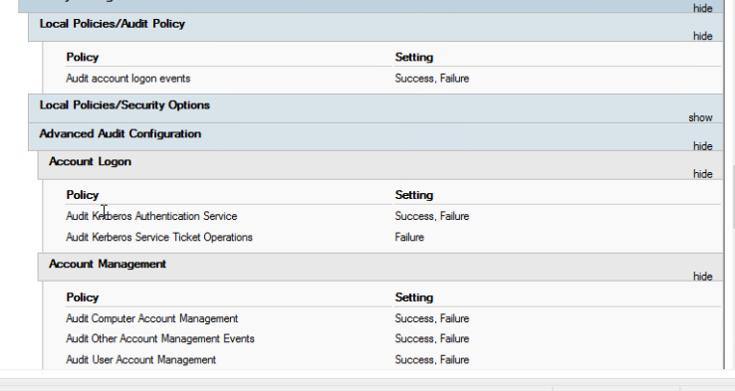
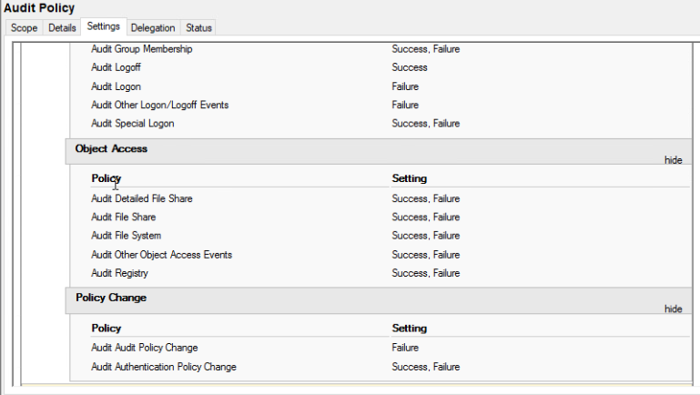

- Configure a shared folder Called Justice and add Superman, Batman, and Wonderwoman to the WinOS
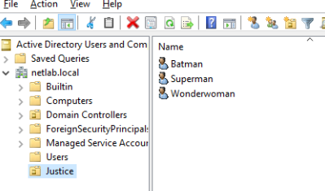
  - Grant Wonderwoman access to the folder.
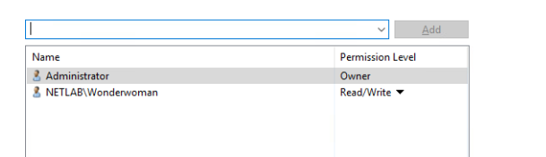
- Test the below activity to ensure logs are generated
  - Log in with an invalid password on Superman and Batman
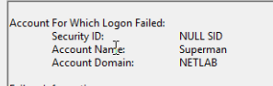
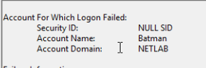
  - Attempt to access the Justice folder as Batman
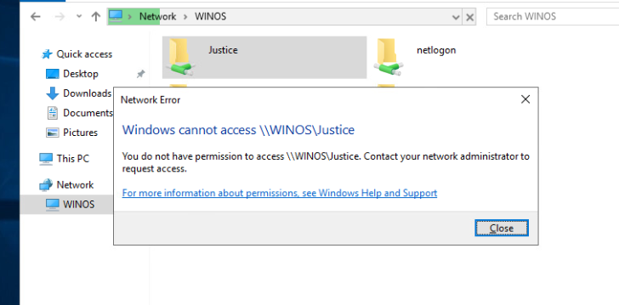
  - Verify that logs are generated with Screenshots

Part B:
- Log on to Security Onion
  - open terminal, and become root
  - run the command so-allow
  - Port Forward the pfSense logs to Security Onion (This is done on pfSense Gui)
  - 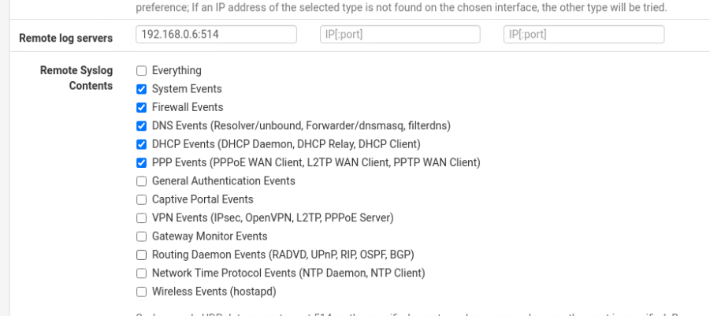
  - Add the rules in Security Onion to allow access to the agents and the firewall
    - so-allow (three Windows agents, 2 Linux agents)
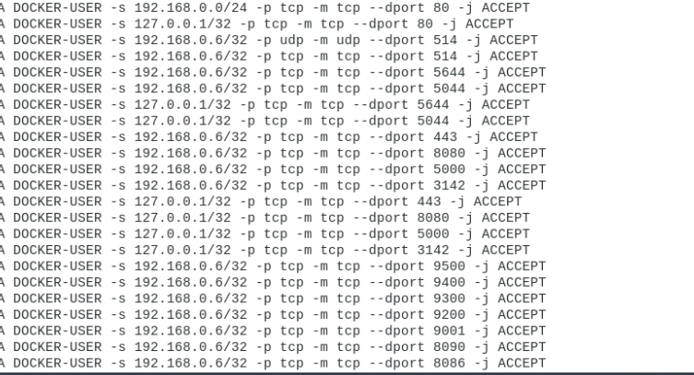
- Log on to the WindowsOS
  - open the browser to 192.168.0.6, log on to Security Onion
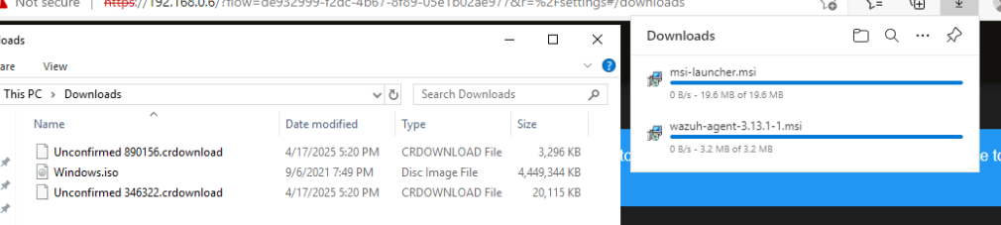
  - Download and install Windows tools
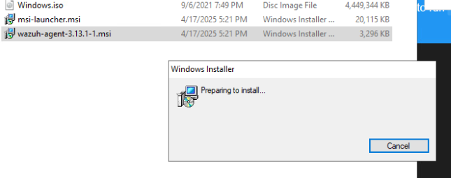
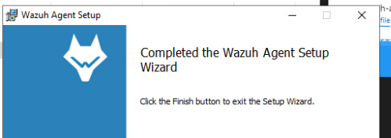
- Log on to UbuntuSRV
  - open the browser to 192.168.0.6, log on to Security Onion
  - Download and install Linux tools
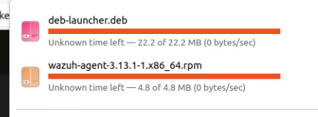
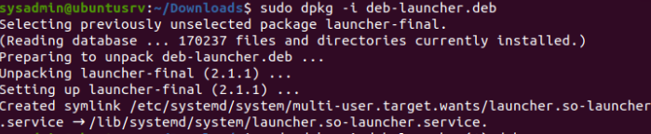
- Due to an issue with Netlab, there is no way to test this environment.
- Please provide enough screenshots and notes to show that you did the work

Part C:
- Review the videos on this link. The times and titles are listed below:Links to an external site.
  - Intro to Security Onion (12:32)
  - Installation part 1 (6:34)
  - Installation part 2 (10:28)
  - Intro to Analysis Tools (20:20)
  - Updating (8:11)
  - Alert Triage and Case Creation (16:11)
  - Threat Hunting (17:20)
  - Detection Engineering (16:19)
  - Course Wrapup (5:01)
  - About three and a half hours of Video
- After viewing the videos, review Netlab --> Security+v4-->Lab 08: Identifying and Analyzing Network/Host Intrusion Detection System (NIDS/HIDS) Alerts:
  - Within this lab, kali scanned some targets, ran Wireshark, saved the pcap (packet data), and imported it into Security Onion for analysis.
  - Does the analysis make sense? Can you follow along with the handout?

The analysis as a demonstration of how the alerts work and the information in them makes sense. The issue is that the way in which it is executed during the initial collection doesn’t quite make sense as we disable the firewall to do the scan essentially. So it could be similar to someone connecting to your network and doing the scan but not similar to an outside attacker scanning the network like how the environment is set up. The overall demonstration is good to show how the individual parts work but the scenario it is set up in is nonsense. I can mentally follow the handout but due to the environment being broken I can not get the pcap to show up and create alerts in sec onion.

